Legend
- ASEAN-5: INO, MAL, PHI, THA, VIE
- Tech Leaders: AUS, CAN, PRC, JPN, KOR, MEX, USA, TAP, SIN, GER, FRA, UKG, ITA
- Subject Industries: c3, c4, c5, c6, c9, c10, c11, c12, c13, c14, c15, c16
- Energy Inputs: c2, c8, c17
- High Tech Sectors: c9, c13, c14, c15

Variables
- lnEI
- Spillover EI
- Share of imported technology
- Energy price ratio
- Import share
- Service share
- Value added per output

Cleaning data
- Master_VA_Output_Nominal
- Nominal Value Added (r64) & Total Output (r69).
- Buyer (Columns): APEC-16 Economies, All Sectors (c1-c35)
- IO table position: Bottom Rows (r64, r69)
- Master_VA_Output_Real
- Real Value Added (r64) & Total Output (r69) at 2010 constant prices.
- Buyer (Columns): APEC-16 Economies, All Sectors (c1-c35)
- IO table position: Bottom Rows (r64, r69)
- Master_Weights_2007
- Bilateral input-output shares (w) for the base year 2007.
- Supplier (Rows): World (63 countries), All Sectors (c1-c35)
- Buyer (Columns): ASEAN-5, Manufacturing (c2-c18)
- IO table position: Intermediate Matrix (Z)
- Master_Weights_2008_2022
- Yearly bilateral input-output shares (wt) for the panel period.
- Supplier (Rows): World (63 countries), All Sectors (c1-c35)
- Buyer (Columns): ASEAN-5, Manufacturing (c2-c18)
- IO table position: Intermediate Matrix (Z)
- Master_Energy_Exp
- Industrial expenditure (USD) on energy-supplying sectors.
- Numerator to calculate Energy Price (P^E) per sector.
- Supplier (Rows): World (63 countries), Energy Sectors (c2, c8, c17)
- Buyer (Columns): ASEAN-5, Manufacturing (c2-c18)
- IO table position: Intermediate Matrix (Z)
- Master_APEC_Energy
- Physical energy consumption in Terajoules (TJ).
- Numerator for Energy Intensity and Supplier Efficiency Shocks.
- 16 APEC Economies, Industry & Transformation Rows

Descriptive statistics
Summary statistics
Table 1: Summary Statistics for ASEAN-5 Manufacturing (2008-2022)
 | Mean | Std. Dev. | Min | Max | Obs
Energy Intensity (Raw) | 9.681 | 6.861 | 2.004 | 44.364 | 975
ln(Energy Intensity) | 2.063 | 0.629 | 0.695 | 3.792 | 975
Energy Spillover | 0.679 | 0.296 | 0.047 | 1.606 | 975
Tech Spillover | 0.802 | 0.978 | 0.013 | 7.713 | 975
Value Added / Output | 0.287 | 0.106 | 0.046 | 0.638 | 975
Relative Energy Price (Raw) | 0.044 | 0.061 | 0.000 | 0.417 | 975
Relative Energy Price (ln) | -4.494 | 3.325 | -19.880 | -0.874 | 975
Service Share | 0.162 | 0.072 | 0.034 | 0.426 | 975
Import Share | 0.225 | 0.119 | 0.038 | 0.657 | 975
Observations | 975
Note: Energy Intensity is measured in TJ per Million USD.
Sectors: c3-c16 excluding c8. Countries: INO, MAL, PHI, THA, VIE.

Summary Statistics: Indonesia
 | Mean | Std. Dev. | Min | Max | Obs
Energy Intensity (Raw) | 6.130 | 2.261 | 3.092 | 13.019 | 195
ln(Energy Intensity) | 1.751 | 0.350 | 1.129 | 2.566 | 195
Energy Spillover | 0.446 | 0.200 | 0.047 | 0.873 | 195
Tech Spillover | 0.696 | 0.747 | 0.013 | 3.303 | 195
Value Added / Output | 0.379 | 0.072 | 0.231 | 0.544 | 195
Relative Energy Price (Raw) | 0.036 | 0.050 | 0.000 | 0.196 | 195
Relative Energy Price (ln) | -4.796 | 3.166 | -18.190 | -1.631 | 195
Service Share | 0.171 | 0.047 | 0.053 | 0.290 | 195
Import Share | 0.171 | 0.109 | 0.040 | 0.525 | 195
Observations | 195

Summary Statistics: Malaysia
 | Mean | Std. Dev. | Min | Max | Obs
Energy Intensity (Raw) | 7.429 | 4.789 | 3.015 | 44.364 | 195
ln(Energy Intensity) | 1.899 | 0.408 | 1.104 | 3.792 | 195
Energy Spillover | 0.733 | 0.195 | 0.300 | 1.180 | 195
Tech Spillover | 1.270 | 1.106 | 0.119 | 4.134 | 195
Value Added / Output | 0.269 | 0.088 | 0.046 | 0.567 | 195
Relative Energy Price (Raw) | 0.050 | 0.040 | 0.000 | 0.186 | 195
Relative Energy Price (ln) | -4.035 | 3.295 | -19.028 | -1.684 | 195
Service Share | 0.134 | 0.050 | 0.037 | 0.325 | 195
Import Share | 0.283 | 0.113 | 0.113 | 0.600 | 195
Observations | 195

Summary Statistics: Philippines
 | Mean | Std. Dev. | Min | Max | Obs
Energy Intensity (Raw) | 4.447 | 1.510 | 2.004 | 11.730 | 195
ln(Energy Intensity) | 1.438 | 0.328 | 0.695 | 2.462 | 195
Energy Spillover | 0.622 | 0.227 | 0.151 | 1.124 | 195
Tech Spillover | 0.554 | 0.869 | 0.013 | 4.757 | 195
Value Added / Output | 0.313 | 0.073 | 0.139 | 0.511 | 195
Relative Energy Price (Raw) | 0.087 | 0.097 | 0.000 | 0.417 | 195
Relative Energy Price (ln) | -3.655 | 3.491 | -19.880 | -0.874 | 195
Service Share | 0.196 | 0.090 | 0.083 | 0.426 | 195
Import Share | 0.193 | 0.106 | 0.038 | 0.545 | 195
Observations | 195

Summary Statistics: Thailand
 | Mean | Std. Dev. | Min | Max | Obs
Energy Intensity (Raw) | 12.027 | 7.047 | 4.038 | 43.599 | 195
ln(Energy Intensity) | 2.356 | 0.496 | 1.396 | 3.775 | 195
Energy Spillover | 0.711 | 0.268 | 0.209 | 1.500 | 195
Tech Spillover | 0.360 | 0.353 | 0.022 | 1.935 | 195
Value Added / Output | 0.279 | 0.129 | 0.066 | 0.638 | 195
Relative Energy Price (Raw) | 0.028 | 0.041 | 0.000 | 0.198 | 195
Relative Energy Price (ln) | -4.853 | 3.167 | -19.106 | -1.621 | 195
Service Share | 0.207 | 0.068 | 0.044 | 0.375 | 195
Import Share | 0.187 | 0.100 | 0.051 | 0.575 | 195
Observations | 195

Summary Statistics: Vietnam
 | Mean | Std. Dev. | Min | Max | Obs
Energy Intensity (Raw) | 18.372 | 5.436 | 8.695 | 37.433 | 195
ln(Energy Intensity) | 2.868 | 0.294 | 2.163 | 3.623 | 195
Energy Spillover | 0.880 | 0.371 | 0.153 | 1.606 | 195
Tech Spillover | 1.131 | 1.240 | 0.050 | 7.713 | 195
Value Added / Output | 0.193 | 0.058 | 0.086 | 0.351 | 195
Relative Energy Price (Raw) | 0.021 | 0.028 | 0.000 | 0.136 | 195
Relative Energy Price (ln) | -5.133 | 3.294 | -18.704 | -1.995 | 195
Service Share | 0.102 | 0.033 | 0.034 | 0.213 | 195
Import Share | 0.291 | 0.111 | 0.078 | 0.657 | 195
Observations | 195

Correlation Matrix
Table 2: Correlation Matrix of Variables
 | (1)
 | ln(Energy Intensity) | Energy Spillover | Tech Spillover | Relative Energy Price (ln) | Service Share | Import Share
ln(Energy Intensity) | 1.000
Energy Spillover | 0.355*** | 1.000
Tech Spillover | 0.188*** | 0.379*** | 1.000
Relative Energy Price (ln) | -0.166*** | 0.028 | -0.046 | 1.000
Service Share | -0.232*** | -0.216*** | -0.264*** | 0.054* | 1.000
Import Share | 0.288*** | 0.498*** | 0.627*** | -0.002 | -0.407*** | 1.000
* p < 0.10, ** p < 0.05, *** p < 0.01

Energy Intensity Trend
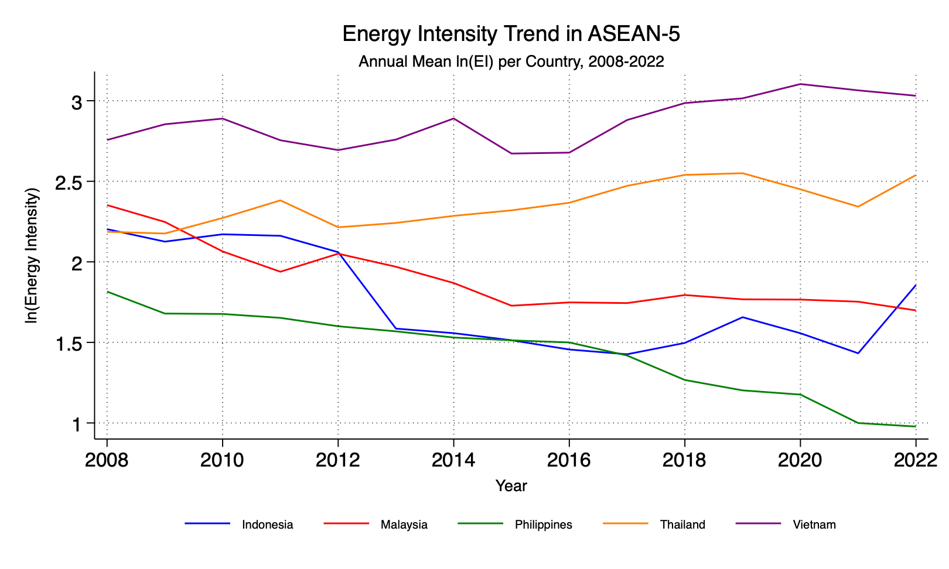

Energy Intensity by Industrial Sector
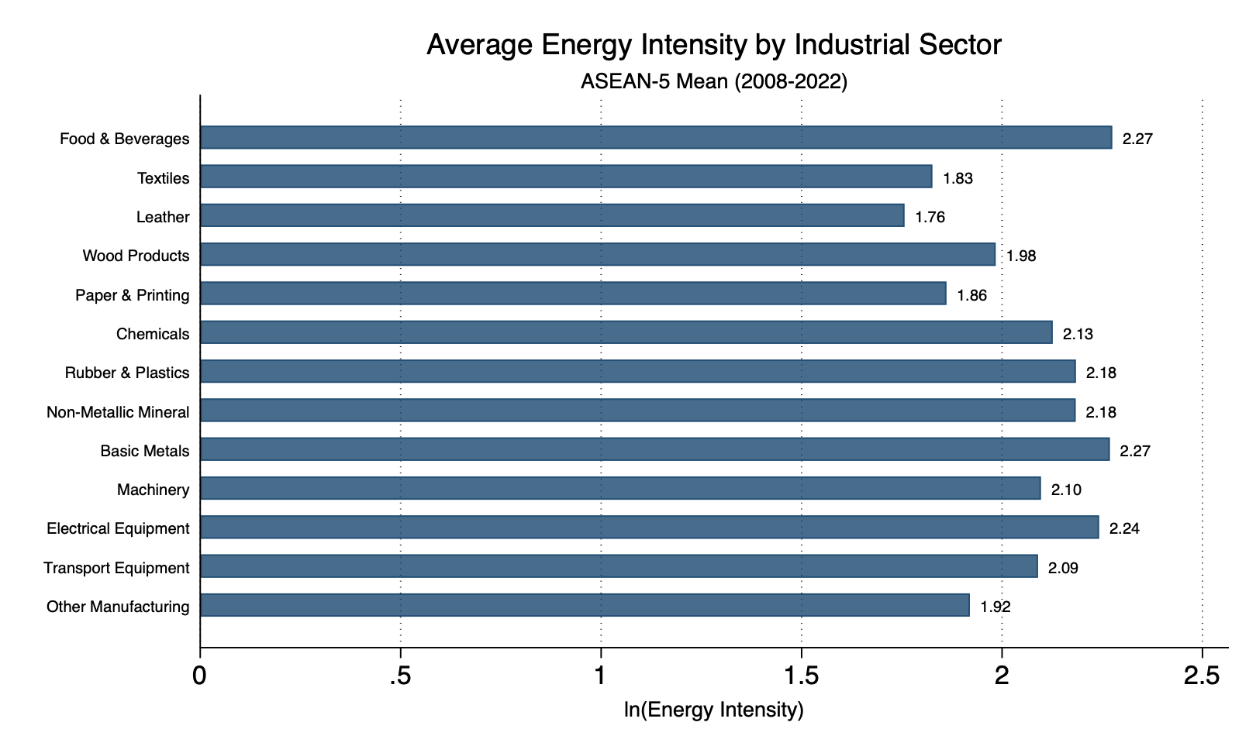

Regression
$ln({EI}_{ijt})=β_{0}+β_{1}{\hat{S}}_{ijt}^{EI}+β_{2}{\hat{S}}_{ijt}^{ImpTech}+δX_{ijt}+α_{ij}+γ_{t}+ε_{ijt}$
Table 3: Baseline Fixed Effects Regression Results
 | (1)
 | ln(Energy Intensity)
Energy Spillover | 0.079
 | (0.072)
Tech Spillover | 0.022
 | (0.025)
Value Added / Output | -4.762***
 | (0.432)
Service Share | 0.158
 | (0.297)
Import Share | -0.086
 | (0.188)
Relative Energy Price (ln) | -0.059***
 | (0.013)
Constant | 2.509***
 | (0.300)
Observations | 975
Within R-squared | 0.718
Standard errors clustered at the industry level.
Year dummies are included but not reported.

Table 3: Bartik 2SLS Regression Results
 | (1)
S^EI (Energy Spillover) | 1.481**
 | (0.650)
S^T (Imported Tech Intake) | -0.040
 | (0.276)
Value Added per Output | -2.831**
 | (1.305)
ln(PE/PQ) | -0.087**
 | (0.038)
Share of service inputs | 0.778
 | (0.671)
Share of imported inputs | -0.047
 | (0.907)
Observations | 975
Adj. R-squared | 0.325
KP LM test (p-val) | 0.078
KP Wald F test | 1.90
Standard errors are clustered at the industry level.
KP LM test refers to the Kleibergen-Paap underidentification test.
KP Wald F test refers to the weak identification test.

Diagnostic Tests: Endogeneity and Instrument Strength
 | (1) | (2) | (3)
 | DWH Test | 1st Stage: S_EI | 1st Stage: S_Tech
S_EI | 1.481** |  | 0.924**
 | (0.650) |  | (0.430)
S_Tech | -0.040 | 0.102***
 | (0.276) | (0.020)
IV_S_EI |  | 0.618***
 |  | (0.122)
IV_S_Tech |  |  | 6.696**
 |  |  | (2.705)
N | 975 | 975 | 975
Robust Endog. (Chi-sq) | 18.694 | . | .
Endog. p-value | 0.0001 | . | .
1st Stage F-stat | . | 25.73 | 6.13
1st Stage p-value | . | 0.0000 | 0.0159
Standard errors in parentheses
Models 1 & 2: Difference-in-Sargan testing H0: Variable is exogenous.
Models 3 & 4: First-stage testing H0: Instrument is weak (Stock-Yogo threshold F > 10).
Standard controls and year fixed effects are included in all models but suppressed for brevity.
* p < 0.10, ** p < 0.05, *** p < 0.01

